CAPT STS ACTIVITIES OVERVIEW (STRANDS I, II, III, IV, and V)
ENERGY USES IN CONNECTICUT STS (2007): (Strand I: Energy Transformations)
The graph below shows the energy consumption for coal and natural gas in Connecticut for 40 years.

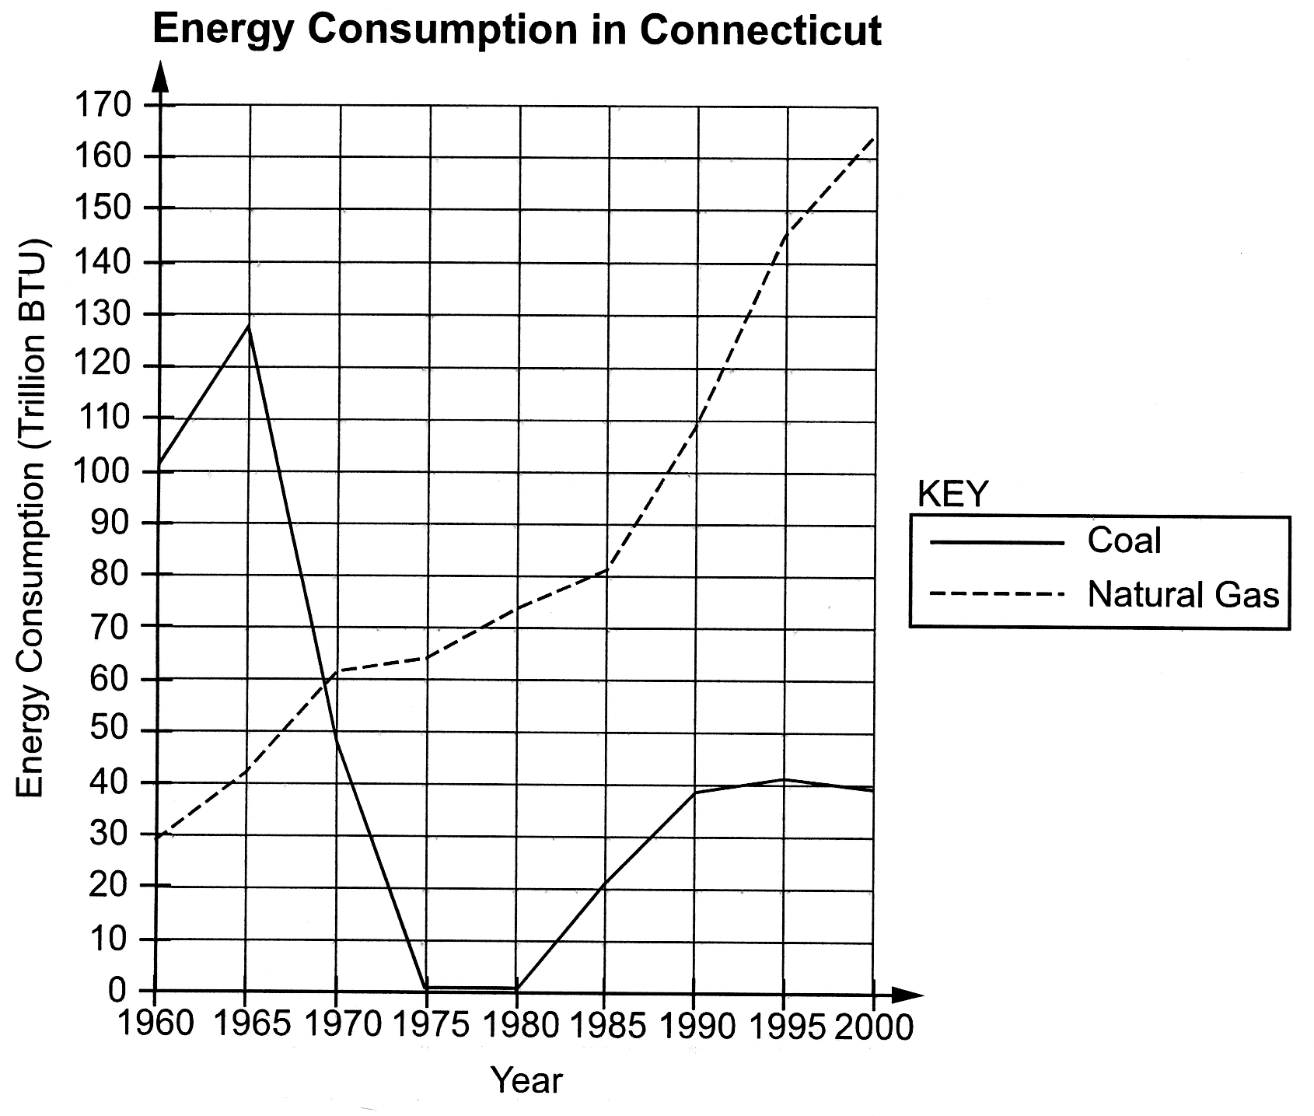

3 Questions:

- Describe the overall trend for coal or natural gas from 1960–2000.

- Make a prediction (in Trillions of BTU) regarding the energy consumption of coal or natural gas for the year 2015.

- Support your prediction with specific quantitative data (i.e., Trillions of BTU's predicted in 2015) from the graph.

Expected Performance: D INQ.7 Assess the reliability of the data that was generated in the
investigation.

Note: Math errors are not penalized.

Possible Correct Responses:

Trends:

- Coal: coal use has varied over the 40-year period, from very high in the 1960s to almost zero in the late 70s. Its use has been moderate since 1990.
- Coal: coal use has declined overall from the beginning of the 40-year period.
- Natural Gas: natural gas use has increased relatively consistently since 1960.

Coal

Predictions:

- The consumption of coal for 2015 will be approximately 40 trillion BTU.
- The consumption of coal will stay level.
- The consumption of coal for 2015 will be less than 40 trillion BTU.
- The consumption of coal will continue to decline.
- The consumption of coal for 2015 cannot be predicted with any degree of confidence.

Support:

- Coal consumption from 1990 to 2000 has been relatively stable at about 40 trillion BTU.
- Coal use since 1990 peaked at 40 trillion BTU and has started to decline.
- Coal use plummeted from almost 130 trillion BTU in 1965 to almost nothing from 1975 to 1980.

Natural Gas

Predictions:

- The consumption of natural gas for 2015 will exceed 165 (or any number above that up to 250) trillion BTU.
- Consumption of natural gas has increased from 30 trillion BTU in 1960 to over 160 trillion BTU in 2000 and there is no evidence that this trend will change.
- The consumption of natural gas for 2015 will continue to increase but at a slower rate.

Support:

- Natural gas consumption has increased 20 to 30 trillion BTU for every 5 years that pass; therefore, it can be expected to continue increasing by this amount.
- Consumption of natural gas has increased from 30 trillion BTU in 1960 to over 160 trillion BTU in 2000, and there is no evidence to suggest that this trend will change in the future.
- From 1985 to 1995, consumption of natural gas increased by 30 trillion BTU for each 5 years that passed. From 1995 to 2000 it dropped off to a 20 trillion BTU increase. It can be expected to keep increasing, but at a slower rate.

Rubric for a Score of 3

The response describes the overall trend of either coal or natural gas and makes a valid prediction. The prediction is supported with specific information from the graph.

Student Responses that Received a Score of 3 for the Energy Use in Connecticut Question

First Student Response Receiving a Score of 3

- The trend from 1960-2000 for coal is that the consumption greatly decreased so that by 1975 the consumption was at zero and slowly rose again to about 38 trillion BTU in 2000. For natural gas the slope gradually rose until 1985 when it shot up from 80 trillion BTU to 163 trillion in 2000.

- In 2015 consumption of coal should slowly decline to about 30 trillion BTU and about 190 trillion BTU for natural gas.

- I came to those conclusions because the consumption of coal rose again and peaked in 1995 at 40 trillion BTU and then was starting to slowly decline. The consumption of natural gas was rising pretty steadily and if the line of the graph was extended it would hit about 190 trillion BTU in the year 2015.

This response describes the overall trends for both coal and natural gas usage from 1960–2000 and then makes a prediction for each. The prediction for coal is supported with specific information from the graph “…the consumption of coal slowly rose again and peaked in 1995 at 40 trillion and then was starting to slowly decline.”

Second Student Response Receiving a Score of 3

- The overall trend for natural gas is that it has greatly increased over the 40 years. It never went down, but always steadily rose and the consumption rose the most from 1985 to 1995.

- In 2015 natural gas will most likely be consumed at a rate of 250 trillion BTU.

- In the past gas consumption has increased by over 80 trillion BTU (1985-2000), about 45 trillion BTU (1975 to 1990), and 70 trillion BTU (1980-1995). Because the trend keeps increasing it will probably rise about 90 trillion BTU to 250 BTU.

This response describes the overall trend for natural gas and also makes an acceptable prediction for natural gas that is supported with specific information from the graph.

POLYMER STS: (Strand II: Chemical Structures and Properties)

You are trying to gauge the risks versus benefits of using plastic products.
Your task is to evaluate the credibility of four articles/websites.

2 Questions: (Use the Assessing the Credibility of Information Matrix on Page 5)

A. Which of the four articles is the MOST credible in your view? Please give at least two
reasons for your choice.

B. Which of the four articles is the LEAST credible in your view? Please give at least two
reasons for your choice.

CREDIBLE:

Information is deemed CREDIBLE when students are confident that it can be trusted and/or believed.

Assessing the Credibility of Information Matrix

Name of the Article | Kind of Site  (.edu, .org,  .com, .net) | Author/  Source | Date of  Publication | Point of View of the  Author/Site | Reliability of the  Information Provided
Plastic Recycling and the Environment | .com | http://www.packagingtoday.com/introenvironment.htm  Packaging Today Newsletter | None  Given | Plastics are convenient, but difficult degrade and recycle. Moreover, the many different types of plastics makes sorting them labor intensive. | This site discusses the down side of using plastics from an industry insider. However, it is not peer reviewed.
Cleaning Up the  Waste Stream: Recycling Plastics | .edu | http://extension.missouri.edu/explore/wasteman/wm0002.htm  University of Missouri Extension Service  John M. Amos | October  1993 | The benefits of recycling are obvious. Recycling extends disposal capacity, saves money in disposal costs, conserves natural resources, creates jobs, and provides a reliable, cost-effective feed stock to industry. | The author is an Engineering Specialist, but there is no resume or biographical information listing his qualifications. However, he is not promoting a product, but an idea. No bibliography.
Why Collect "All Plastic Bottles?" | .org | http://www.allplasticbottles.org/  allplasticbottles.org | 2005 | The article is a plea for collecting all plastic bottles not just recyclable PETE and HDPE because this will remove the confusion that the public has about plastic recyclables, hence recycling will increase overall. | Given that there is no identified author we do not know if recycling all plastics bottles is feasible. Also there are no links provided, so the article's substance is a little bit suspect in terms of reliability.
Plastic in Our Oceans | .edu | http://www.whoi.edu/science/B/people/kamaral/plasticsarticle.html  Wood's Hole Oceanographic Institution (WHOI)  Kimberly Amaral | None  Given | The author is very thorough in terms of making a case for the problem of plastics littering the ocean. Moreover, she presents a comprehensive what we can do list. The article definitely appeals to one's conscience to makes its primary point. | This appears to be a very reliable article given that there are links to other resources, cited references, and a named author from a respected organization. (WHOI).
Expected Performance: D INQ.10 Communicate about science in different formats, using relevant
science vocabulary, supporting evidence and clear logic.

Possible Correct Responses:

Most Credible: (Article = Plastics in Our Oceans)

- Links to other resources
- Cited references
- Named author
- A respected organization
- A .edu article

Least Credible: (Article = Plastic Recycling and the Environment)

- No named author
- Not peer reviewed
- No publication date
- A .com article

Rubric for a Score of 3

The response provides at least two appropriate reasons for the article's credibility from the matrix.

Student Responses that Received a Score of 3 for the Energy Use in Connecticut Question

First Student Response Receiving a Score of 3

- The Plastics in Our Oceans article is the MOST credible because there are links to other sources and cited references.

- The Plastic Recycling and the Environment article is the LEAST credible because there is NO named author and it is from a commercial (.com) business.

This response gives two accepted reasons why the student feels that the Plastics in Our Oceans article is the MOST credible of the four. Also, this response gives two accepted reasons why the student feels that The Plastic Recycling and the Environment article is the LEAST credible of the four.

Second Student Response Receiving a Score of 3

- The Plastics in Our Oceans article is the MOST credible because there is a named author from a respected organization (WHOI). Moreover, it is from an educational (.edu) site.

- The Plastic Recycling and the Environment article is the LEAST credible because it is NOT peer reviewed and there is no publication date.

This response gives two accepted reasons why the student feels that the Plastics in Our Oceans article is the MOST credible of the four. Also, this response gives two accepted reasons why the student feels that The Plastic Recycling and the Environment article is the LEAST credible of the four.

CONNECTICUT BROWNFIELD SITES STS (2007): (Strand III: Global Interdependence)
A process called phytoremediation has been developed that uses plants to remove contaminants from soils and water. Suppose a contaminated area (a Brownfield site) in your town is being considered for this process.
Identify at least three questions that would need to be answered before starting such a program.
Expected Performance: D INQ.1 Identify questions that can be answered through scientific
investigation.

Possible Correct Responses:

- What is/were the sources of contamination?
- What are/were the contaminants of concern?
- What is the extent of the affected property?
- How deep does the contamination extend into the sediment?
- What are the potential effects on the local ecosystem/food webs?
- What type of ecological restoration is being sought (recreation, residential, etc.)?
- What is the timeframe needed for total restoration?
- What is the cost associated with this program compared to other programs?
- What special resources (tools, people, etc.) are required?
- Other acceptable questions.

Rubric for a Score of 3

The response provides at least three relevant questions that would need to be answered before a town implements a phytoremediation program.

Student Responses that Received a Score of 3 for the Brownfields Question

First Student Response Receiving a Score of 3

- Can the area support plant life?
- Where is the funding coming from?
- What will be done with the plants after contamination is completed?
- How long will the process take?
The response above provides several (4) valid questions that would need to be answered before using a phytoremediation process to decontaminate a Brownfield site.

Second Student Response Receiving a Score of 3

One question that needs to be identified is what contaminants are in the soils and water in the first place? You need to know this because it will be easier to find out how to remove the contaminants.
The second question I have would be how big is the Brownfield site? I need to know this simply because I would need to know how the amount of materials and supplies that are needed to remove the contaminants.
My last question is how does phytoremediation work? I would need to know this just in case we need other processes or supplies to remove the contaminants.
This response provides three valid questions: “…what contaminants are in the soils and water,” “how big is Brownfield site?” and “how does phytoremediation work?” This response also provides elaboration as to why questions are being asked.

BIOENGINEERED FOOD STS (2008): (Strand IV: Cell Chemistry and Biotechnology)
Suppose a consumer reads the following news release regarding the safety of a genetically modified (GM) food product.

GM Grains Pose No Health Risk

Researchers report that genetically modified (GM) grains fed to test mice
have no negative impact on health. In two trials, the offspring of mice fed
GM grain for three weeks showed a similar survival rate as the offspring
of mice that were fed non-GM grain. The trials have been called as a
victory for GM food producers. A spokesperson for the research group
stated that “it is highly unlikely for any unintended side effects to occur as
a result of human consumption of GM grains.”

Provide three (3) reasons a consumer should question the conclusions presented in this news release.

Expected Performance: D INQ.2 Read, interpret and examine the credibility and validity of
scientific claims in different sources of information.

Possible Correct Responses:

- No data are presented to back up the statement(s).
- “Similar survival rate” is vague; how similar was the survival rate?
- Survival is only one aspect of health; no other potential side-effects were mentioned (immune responses, tumor formation, etc.)
- The conclusions were based on a three-week study; what about long-term consumption of GM grains?
- There is no indication of who the researchers were affiliated with to determine whether they may have had an agenda/bias.
- Two trials are not sufficient to draw a definitive conclusion.
- Just because it does not affect mice does not mean it will not affect humans.
- Other acceptable questions.

Rubric for a Score of 3

The response provides three reasons a consumer should question the conclusions presented in the news release.

Student Responses that Received a Score of 3 for the Energy Use in Connecticut Question

First Student Response Receiving a Score of 3

It's unlikely to get side effects, but what are the side effects that can occur. Also they say that they fed mice Genetically Modified (GM) foods and it was similar to the Non-genetically modified foods, how similar and how not similar. They fed mice but humans are not mice.

This response provides three acceptable reasons that a consumer should question the conclusions presented in the news release: “It’s unlikely to get side effects, but what are the side effects?”; “they fed mice GM and it was similar to the non-GM, how similar and how not similar?”; and “they fed mice, but humans are not mice.”

Second Student Response Receiving a Score of 3

One reason a consumer should question the results is that the article never states who conducted the experiment. The "researchers" could work for a GM food producer and have a biased opinion that could affect the results. Also, only two trials were conducted, not enough to draw a valid conclusion. Consumers should also question whether the effects of GM food on mice are directly comparable to humans. GM foods might have different affects on each.

This response provides three acceptable reasons that a consumer should question the conclusions presented in the news release: “the article never states who conducted the experiment. The researchers could work for a GM food producer and have a bias opinion that could affect results”; “only two trials were conducted, not enough to draw a valid conclusion”; and “question whether the effects of GM food on mice are directly comparable to humans…might have different effects on each.”

HUMAN POPULATION DYNAMICS STS (2009): (Strand V: Genetics, Evolution, and
Biodiversity)

The graphs below show the population of Taiwan in 2000 and the predicted population of Taiwan in 2050.

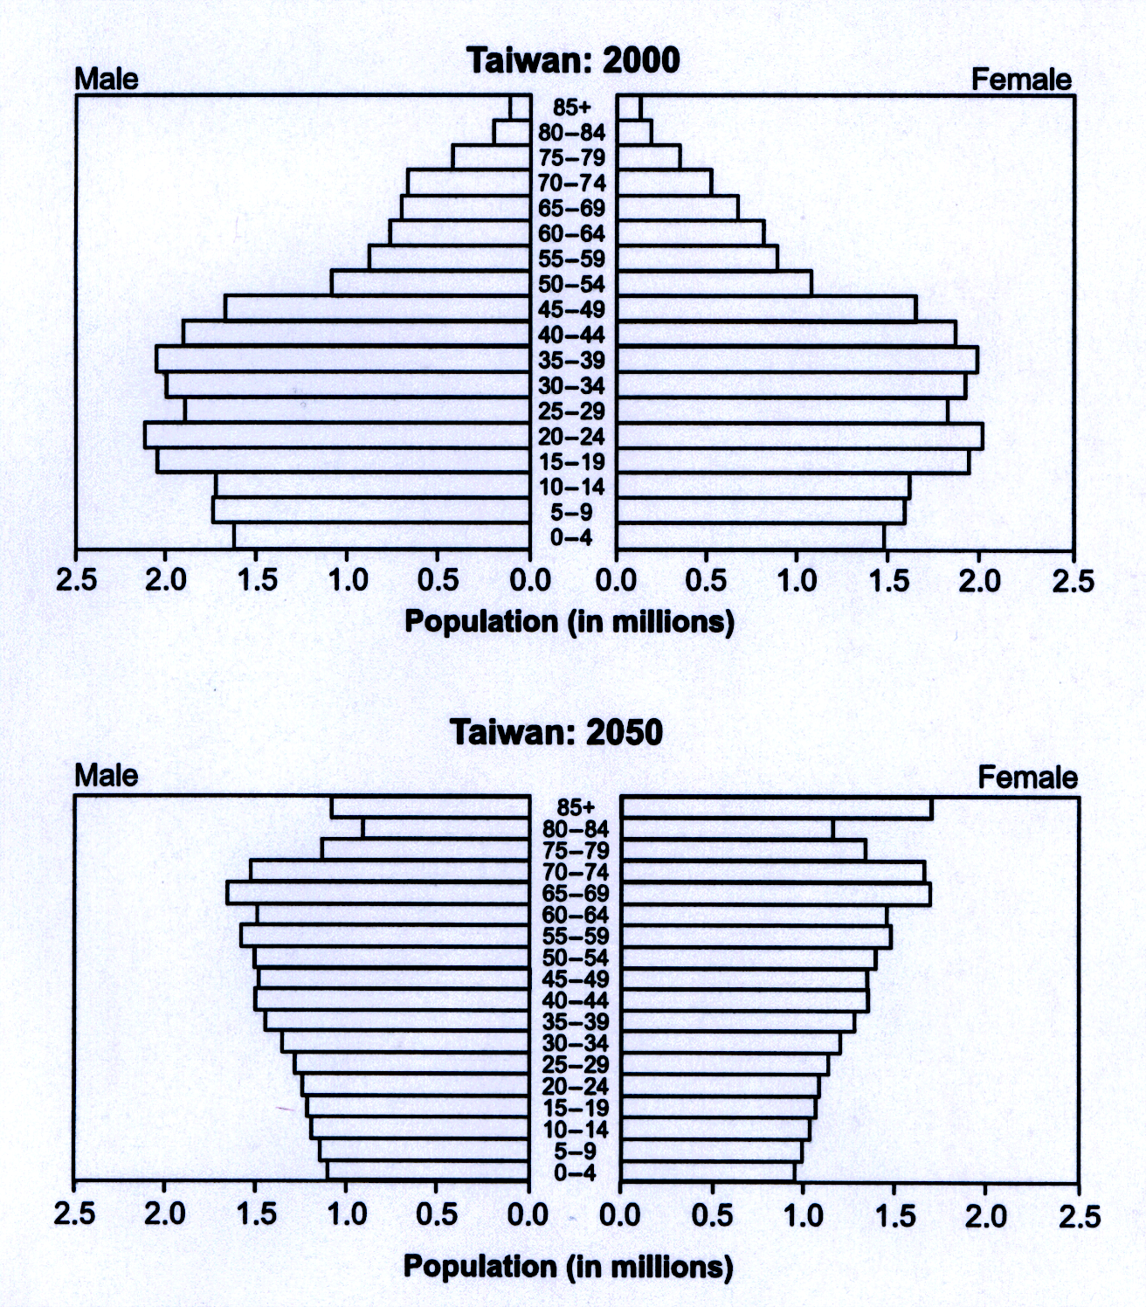

Use the graphs to:

- Draw a conclusion regarding the overall population change in Taiwan from 2000 to 2050.

- Describe two factors that may contribute to the predicted population changes from 2000
to 2050.

Expected Performance: D INQ.7 Assess the reliability of the data that was generated in the
investigation.

Possible Correct Responses:

Conclusion:

- The population in Taiwan will begin to stabilize over the next 50 years.
- Population growth in Taiwan will slow down over the next 50 years.
- There will be more older people and less younger people in 2050.
- Other acceptable responses

Factors:

- Reproductive rates could decline some (people of reproductive age having fewer children).
- Longevity could increase (increased survival rate for the elderly).
- Mass immigration to other countries for various reasons.
- Increased access to healthcare or better healthcare provisions.
- Other acceptable responses

Rubric for a Score of 3

The response draws a valid conclusion regarding the overall population change in Taiwan from 2000 to 2050 and describes two factors that may contribute to the predicted population changes from 2000 to 2050.

Student Responses that Received a Score of 3 for the Human Population Dynamics Question

First Student Response Receiving a Score of 3

According to the graphs, in 2050 the majority of the populations will be over 40 compared to 2000 when there were more people in the age 40 or younger group.

It is possible that the young population went down because there may be a high infant mortality rate in Taiwan. Also, the birth rate in 2050 could be lower than the birth rate of Taiwan in 2000.

This response provides a valid conclusion regarding the overall population change in Taiwan from 2000 to 2050: “…in 2050, the majority of the population will be over 40, compared to in 2000 when there were more people in the age 40 or younger group.” Two acceptable factors that may contribute to the predicted population changes from 2000 to 2050 are also given: “high infant mortality rate”; “the birth rate in 2050 could be lower than the birth rate … in 2000.

Second Student Response Receiving a Score of 3

- The population in Taiwan goes from a generally young population in 2000 to an older population in 2050.

- This change could be because the birth rate dropped. There are less people of a young age because fewer are being born. The older population could be due to a higher life expectancy.

This response provides a valid conclusion regarding the overall population change in Taiwan from 2000 to 2050: “The population in Taiwan goes from a generally young population in 2000 to an older population in 2050.” Two acceptable factors that may contribute to the predicted population changes from 2000 to 2050 are described as well: “the birth rate dropped”; “the older population could be due to a higher life expectancy.”

NOTE:

All the questions, the performance expectations, possible answers, rubrics, student responses, and response overviews came from the following Connecticut State Department of Education (CSDE) website:

http://www.csde.state.ct.us/public/cedar/assessment/capt/released_items.htm

